Little Red Riding Hood Visual Story

The Characters

Little Red
A kind and thoughtful little girl who loves her family, she makes friends easily and enjoys helping others. Little Red wears a red hood that Grandmother gave to her.
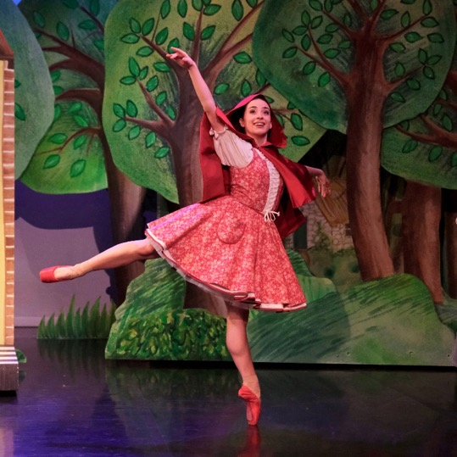

Father
Little Red’s father, he plays games with her and helps her bake a cake for Grandmother.
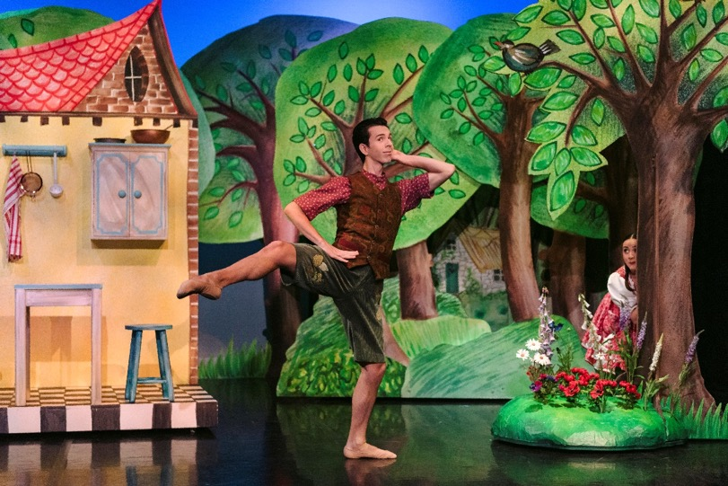

Mother
Little Red’s mother, she worries when Little Red walks to Grandmother’s house by herself.
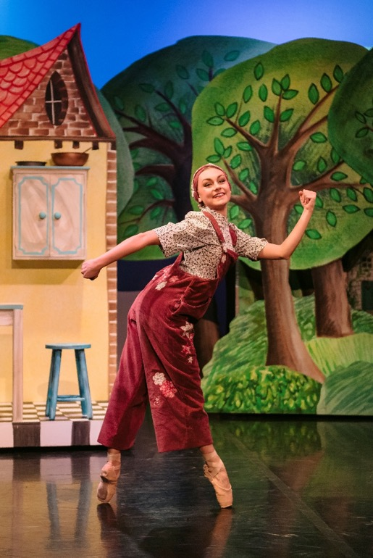

Grandmother
Little Red’s grandmother, she gives her granddaughter a red hood as a gift, but when she gets ill she has to stay at home in bed. Grandmother lives in the forest
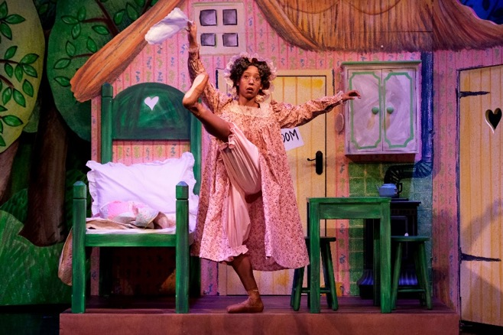

Wolf
Not such a big, bad wolf! Stylish and gentle, he likes flowers and gets very hungry when he is unable to find food. All the other animals are scared of him and they run away.
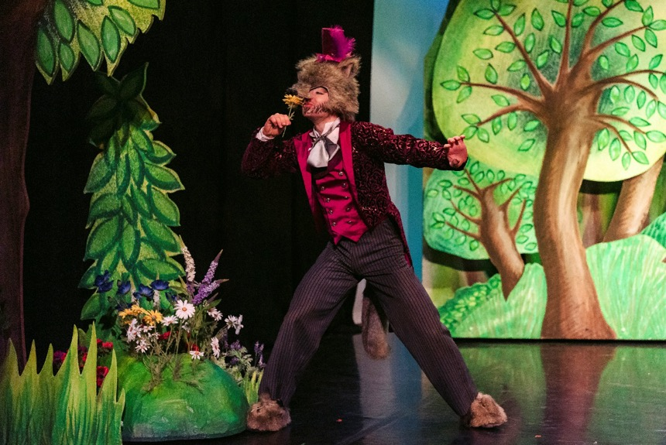

Bear
Bear sells honey to the other animals in the forest, and soon learns not to be afraid of Wolf with some help from Little Red.
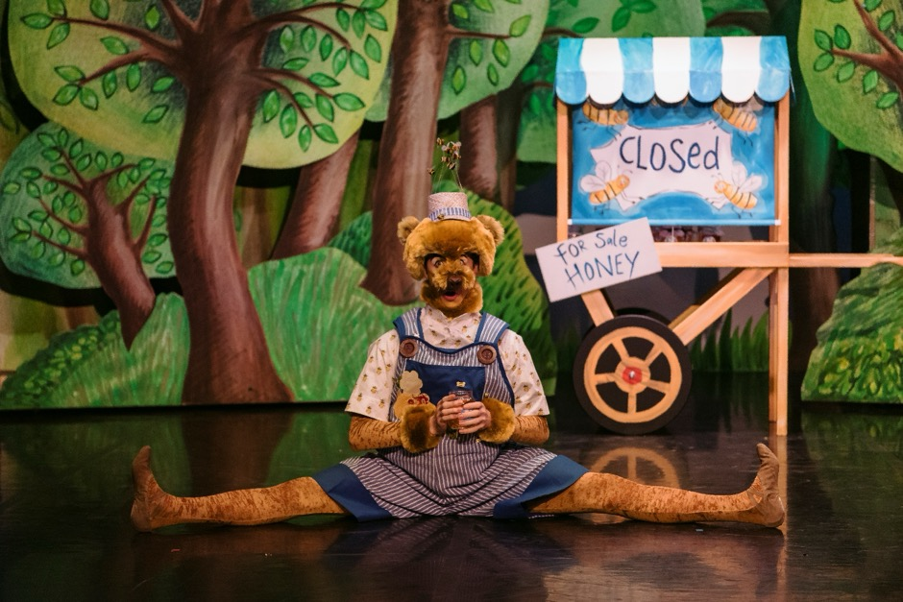

Fox
Fox lives in the forest and buys honey from Bear, but is scared of wolf and runs away from him.
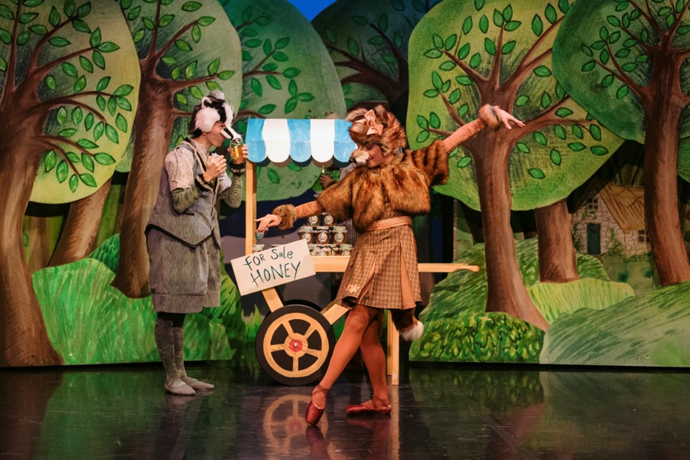
Badger
Badger also lives in the forest and buys honey from Bear, but is scared of wolf and runs away from him.
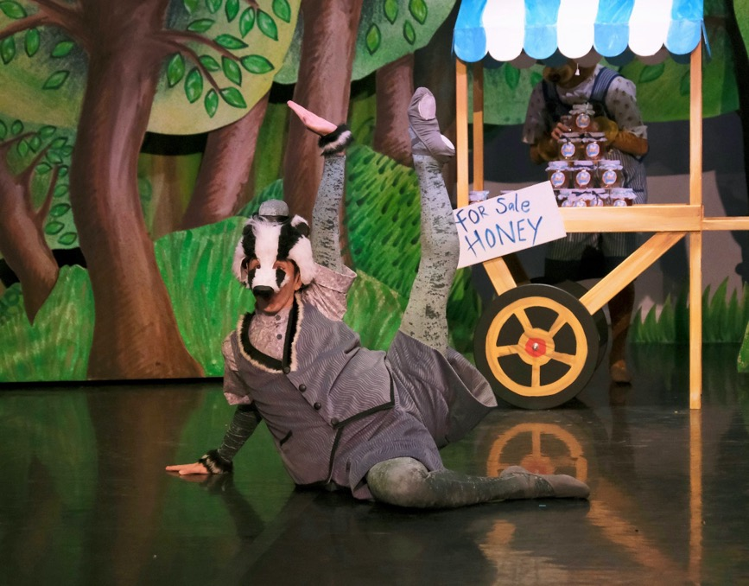
The characters will be played by different dancers on different days, but their costumes will always stay the same.

Stop reading here if you’d rather not know what happens in the story!

The Story
A little girl is having a tea party with her mother, father and grandmother. Grandmother gives her a new red hood, and she puts it on.
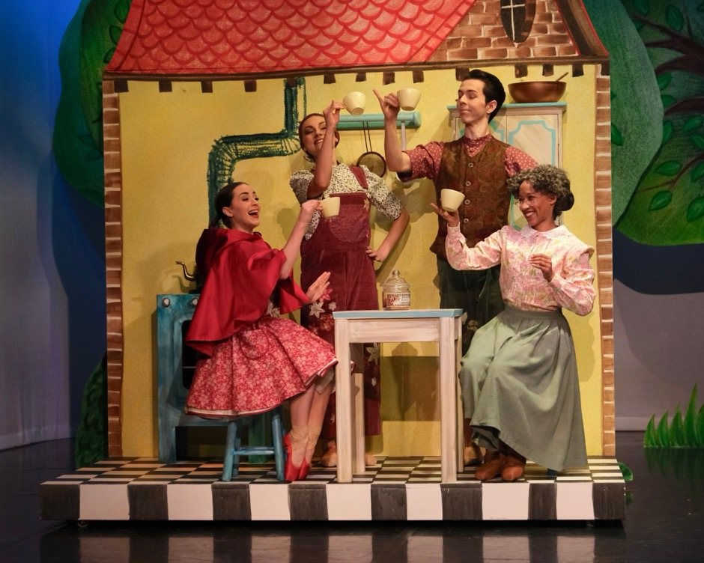
Grandmother starts to feel ill, so Mother takes her home. Little Red and Father decide to bake a cake to help Grandmother feel better.
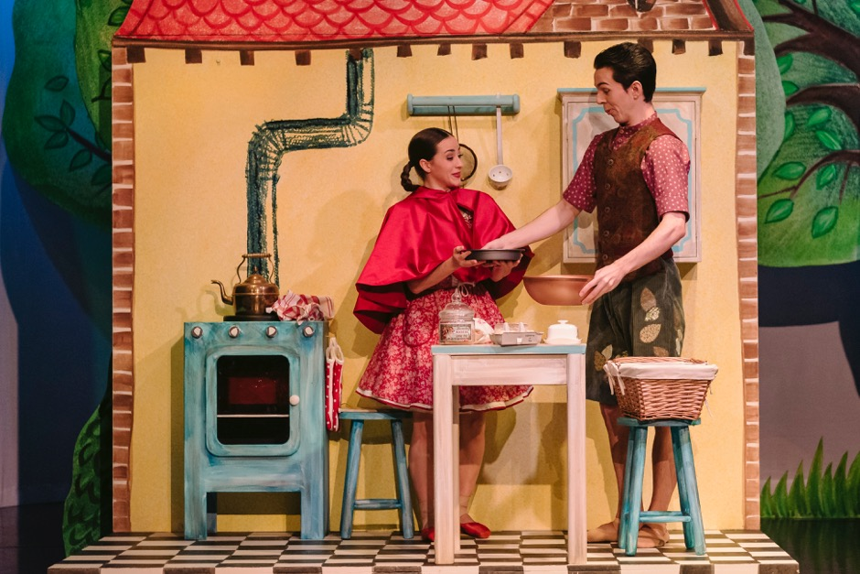
In the nearby forest a wolf is taking a walk.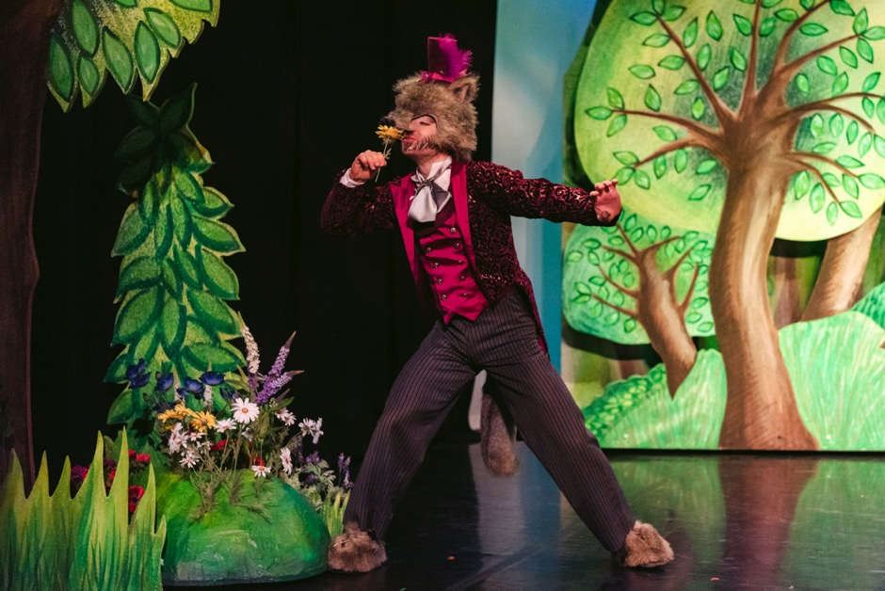
A bear is selling honey jars to a fox and badger as he passes.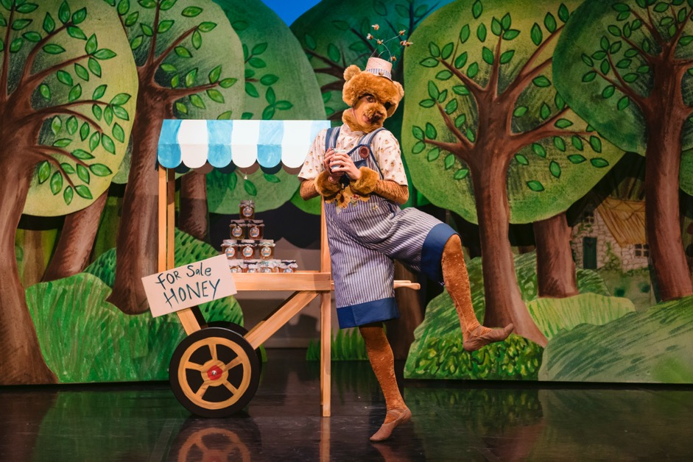
Wolf is delighted as he is very hungry, but the other animals are frightened and run away.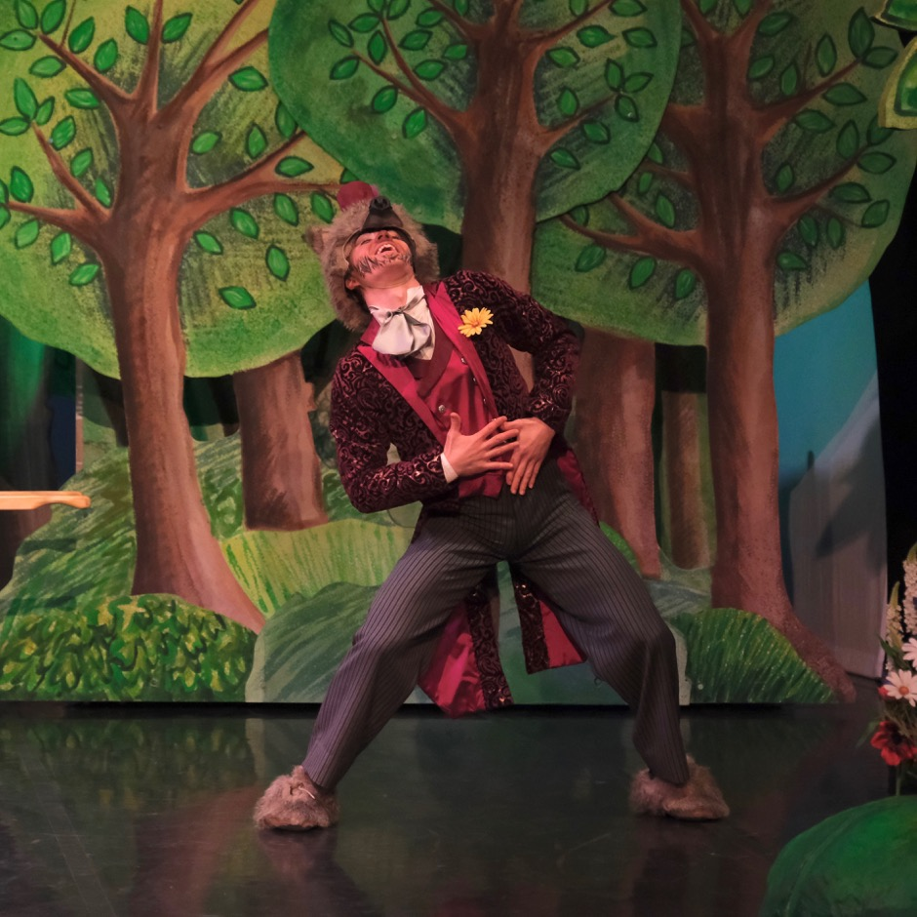
Little Red sets off to Grandmother’s house with the cake and a tin of biscuits. Her parents worry about her walking through the forest alone.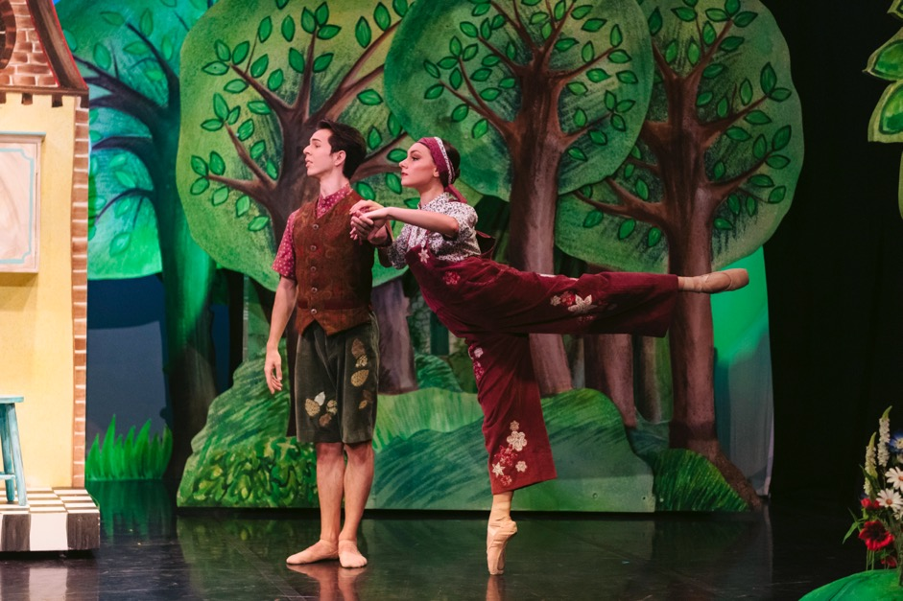
Wolf sees Little Red in the forest, he smells the treats and offers to buy the food, but Little Red tells him they are for her sick grandmother.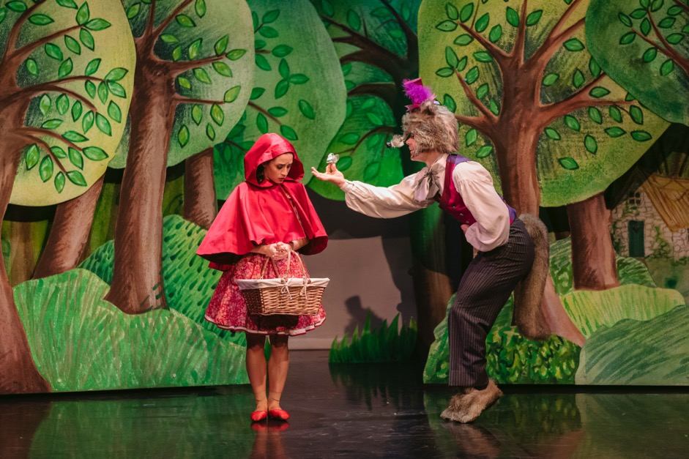
Wolf thinks he could sneak into grandmother’s house to look for food. He suggests Little Red pick some of the flowers, and whilst she is distracted, he hurries off.
Bear returns with his honey cart and Little Red buys some honey for grandmother.
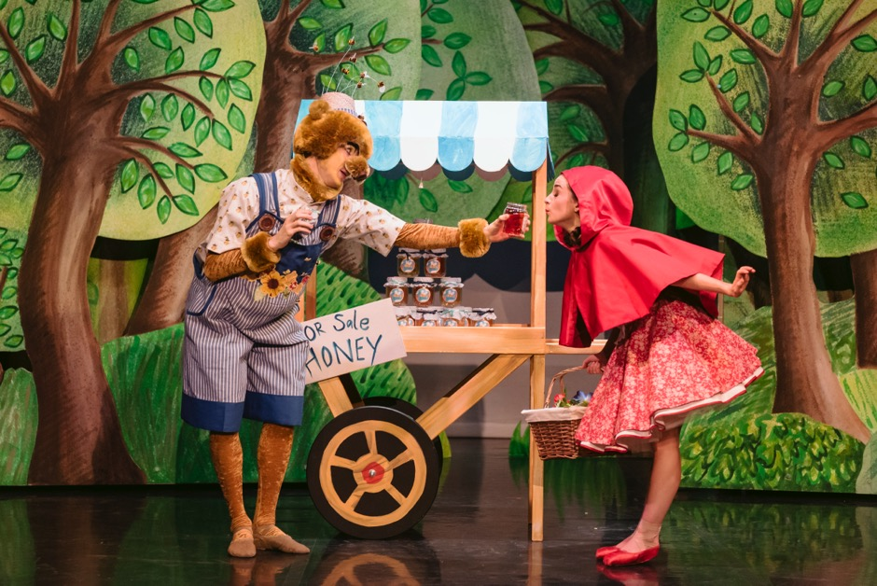

In her house in the forest, Grandmother is ill in bed. When the doorbell rings she opens the door but no one is there.
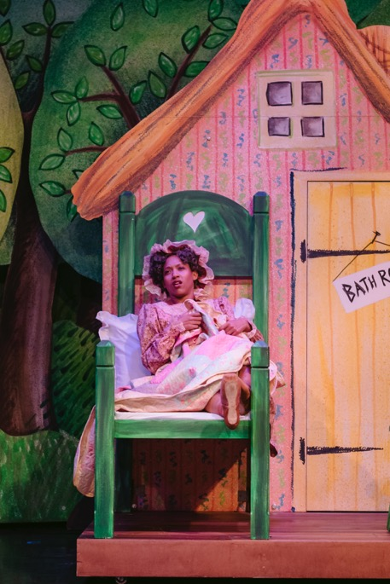
Meanwhile, Wolf has slipped inside the house and hides under the bed, hoping he can find some food in Grandmother’s house.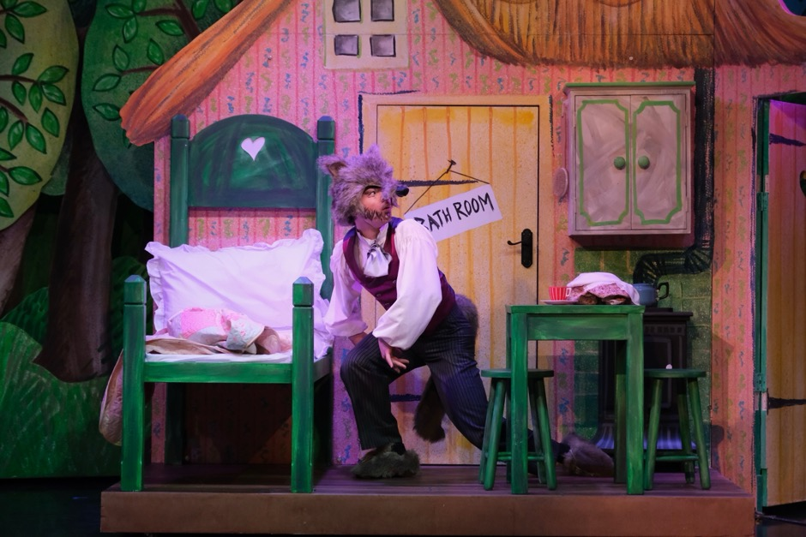
Grandmother decides to go and have a hot bath.
Wolf searches for food, but Little Red arrives so he puts on Grandmother’s pyjamas and hat as a disguise.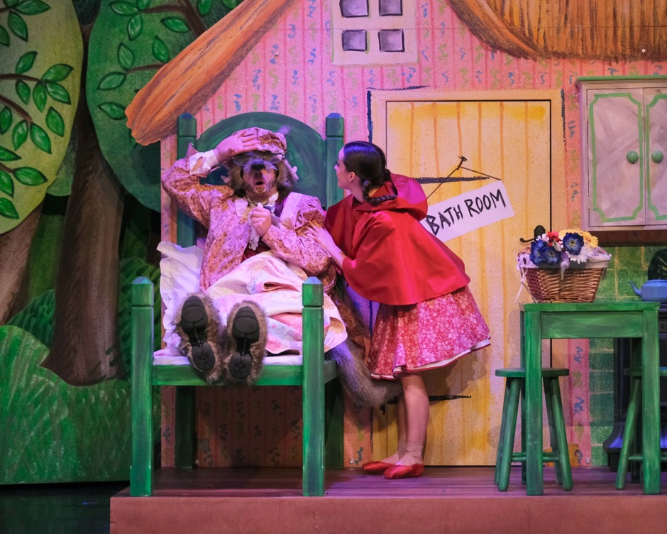
Little Red gives him the basket of goodies, and the starving wolf devours them in one go.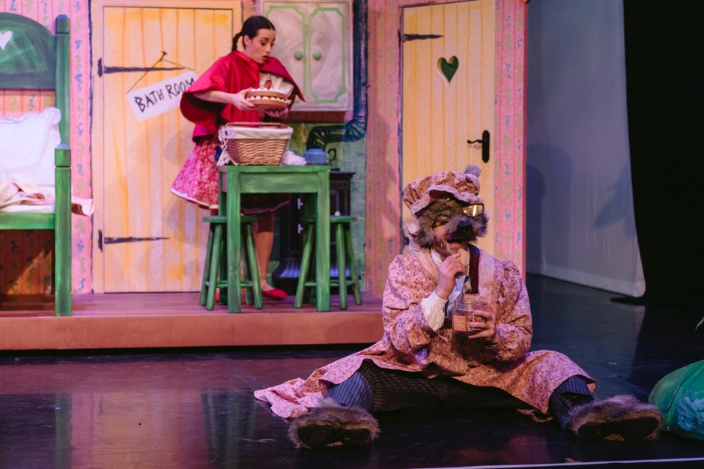
Little Red is surprised by this lack of manners and takes a closer look. Grandmother looks strange indeed, with very big eyes, ears and teeth! 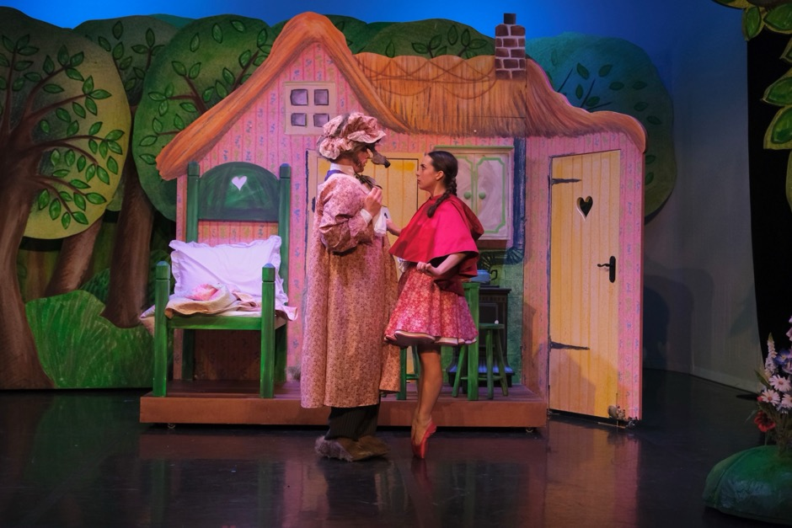
Little Red pulls off the hat and realises it’s the wolf! He explains he was really hungry, and she goes to fetch Grandmother.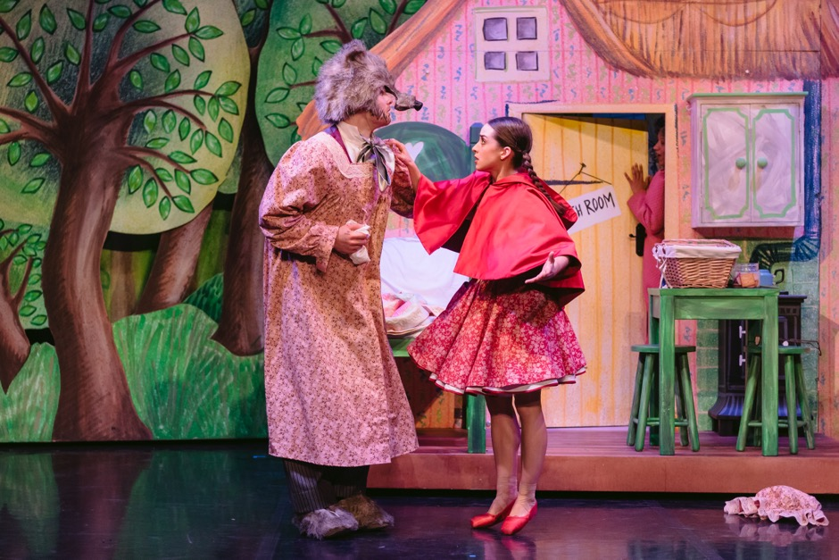
Wolf is very sorry for his behaviour. He only ate the treats because he had not been able to get any food all day, as everyone fears him and runs away at first sight. Little Red feels sorry for Wolf and decides to help him.
They return to the forest and find Bear hiding behind the honey cart. Little Red explains there is no reason to be scared and takes him to meet Wolf.
Bear apologises and offers him free honey. Wolf thanks Bear, and thanks Little Red for her help, and the three of them dance together!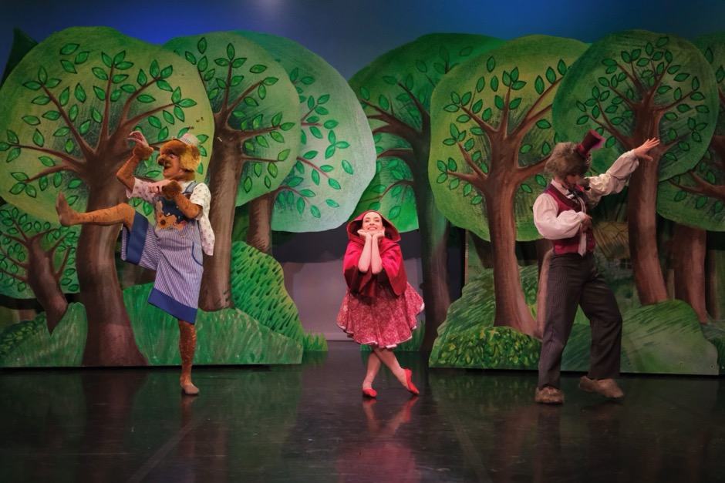
Sometime later Little Red is having another tea party, only this time she has invited her new friends, Wolf and Bear! The house is filled with love and laughter, everyone stands up and joins together in a dance.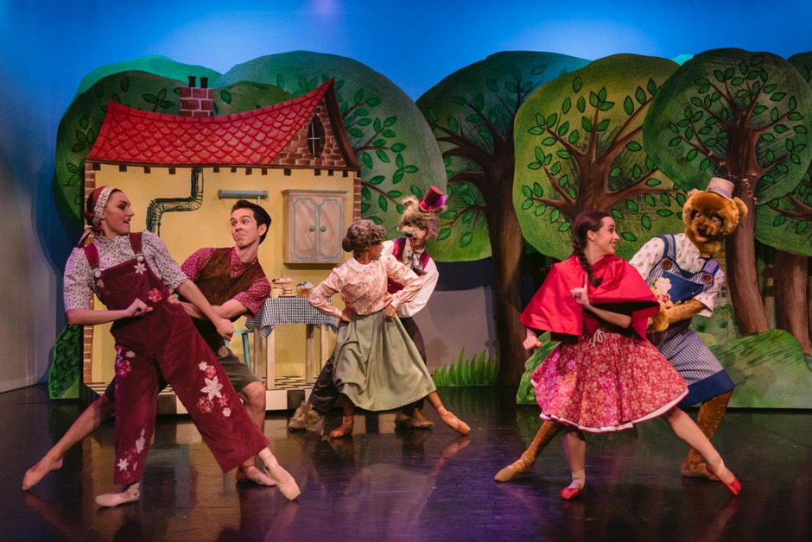
The End
The audience will clap and cheer and the performers will line up on stage and take a bow.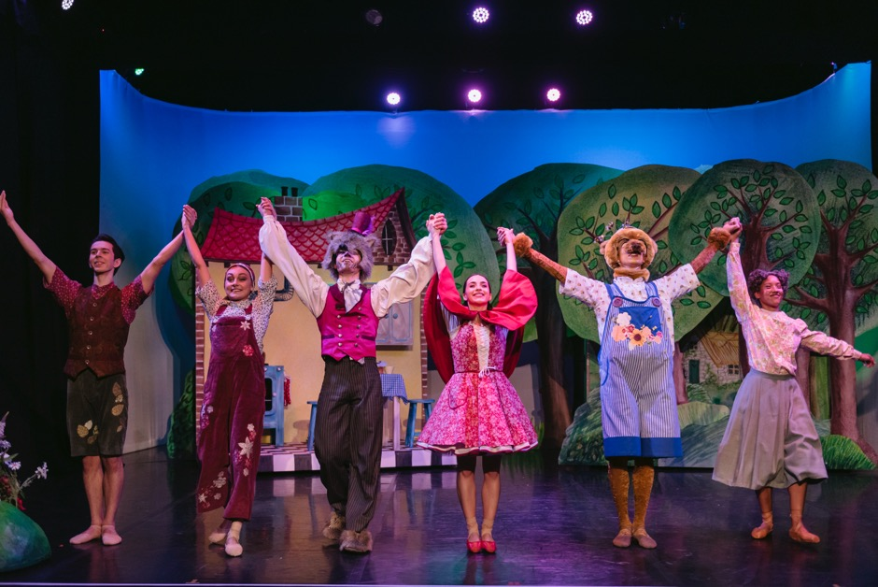
Images by Brian Slater and Drew Forsyth

